**Defined Architecture of the ANN Model**

**Introduction**  
Businesses have a major problem with customer "churn" since it is usually more cost-effective to hold on to current customers than to get new ones. Using characteristics such as demographics, contract type, and service consumption, this research aims to build an ANN-based prediction model that can identify consumers who are likely to churn. A total of 7,043 client records including information such as gender, duration, and monthly costs make up the dataset.

# **Methodology**

**Data Preprocessing**  
Using one-hot encoding, the dataset's categorical variables—like gender and contract type—were elevated to numerical values. We used "StandardScaler" to scale all features uniformly. Subsequently, an 80/20 split was applied to the data, dividing it into training and testing sets.

**Model Architecture**  
We went with the ANN model because of how well it detects intricate patterns in the data. The design consists of one input layer that is proportional to the feature count, two hidden layers activated by ReLU, and one output layer for binary classification that uses sigmoid activation. Model construction included the use of the binary cross-entropy loss function and the Adam optimizer.

**Results**

Model Performance  
The test set showed that the model was 81.1% accurate. Out of a total of 914 results, 229 were genuine positives, 122 were false positives, and 144 were false negatives, according to the confusion matrix. According to the classification report, the churn class had an F1-score of 0.63, recall of 0.61, and accuracy of 0.65.

Model Accuracy and Loss Plots  
After 50 iterations, the model's accuracy levelled out at around 80%, according to the loss and accuracy graphs. The following charts illustrate the model's training and performance visually.

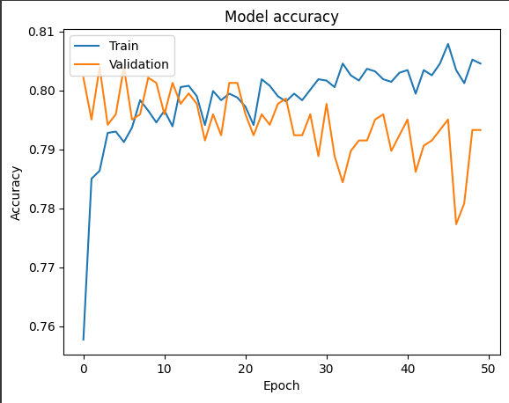

Figure 1 Model Accuracy Over 50 Epochs

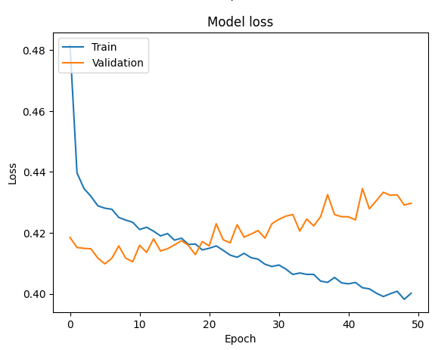

Figure 2 Model Loss Over 50 Epochs